Panera Chicken and Wild Rice Soup
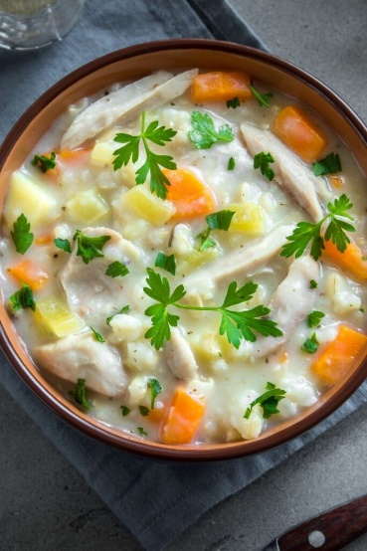

INGREDIENTS
- 6 cups chicken broth
- 2 boneless chicken boneless breast halves, cooked and cubed
- 1 (6-ounce) package quick-cooking long-grain wild rice blend + seasoning packet*
- 1/2 teaspoon ground black pepper
- 1/2 cup all-purpose flour
- 3/4 cup butter
- 1 cup carrot, diced
- 1 cup celery, diced
- 1 cup onion, diced
- 3 cups light cream

DIRECTIONS
- Combine the pepper and flour. Set the mixture aside.
- In a large pot over medium heat, combine the broth and chicken and bring it to a boil. Stir in the rice. Cover and remove it from heat.
- Melt the butter in a medium saucepan over medium heat. Add the carrots, celery, and onion and cook, stirring occasionally, for 5 minutes. Stir in the rice seasoning packet and cook further until the vegetables are softened, about 5 more minutes.
- Add the pepper-flour mixture and stir constantly until a roux is formed. Continue to stir for 3-4 more minutes to cook the flour.
- Gradually whisk in the cream until smooth. Cook it for 5 more minutes, or until it’s thick.
- Pour the cream broth into the pot of chicken and rice. Cook it over medium heat until the rice is ready, about 15 to 20 minutes. Serve it and enjoy!
- *Alternative Method for Traditional Rice:
Cook the rice in the broth for 25 minutes over medium heat before combining it with the cream stock.

